Investigating Unknown White Powders   
**Task 10** Name:

Due: _____________________

In many industries it is useful for scientists to be able to identify unknown substances. You can measure several unknown properties of a substance to help identify it, or some properties may need to be tested against a known substance.

For this task you will be provided with samples of BaCl2, Zn(NO3)2, Na2CO3, and CaCO3 that have been randomly labelled A, B, C, and D.

You will need to design an experiment to correctly identify each sample. You will only have access to the above unlabelled substances, distilled water (H2O), and lime water (an aqueous solution containing Ca(OH)2).

In pairs, come up with a method and get this checked by your teacher before continuing. This will include a list of the observations you will observe for positive and negative results. You will also be expected to write full and ionic equations for each of the reactions you trial.

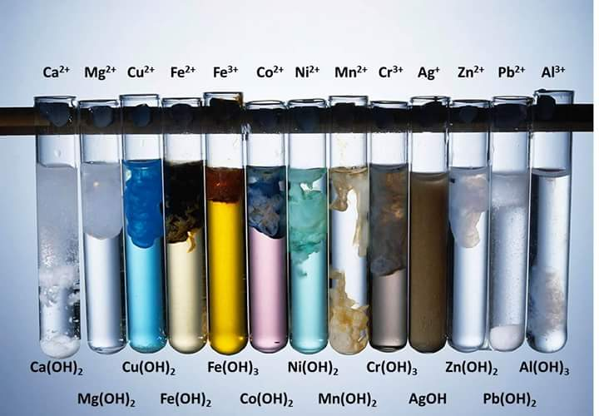

On the date on SEQTA, you will sit a validation based on the experiment. You will need to replicate all the skills you put into practice during the experiment. This includes basic experimental information, such as the variables involved, chemical reactions that take place, what the aim of the experiment was, etc.

**Reaction 1:**

**Ionic Equation:**

**Observations:**

**Reaction 2:**

**Ionic Equation:**

**Observations:**

**Reaction 3:**

**Ionic Equation:**

**Observations:**

**Other Observations:**